Using Twitter to locate the latest research on your topic:
Step 1: Login to Twitter and keyword search your topic

Step 2: Once you hit enter, you will see a listing of tweets (which updates as new tweets are added)
Step 3:
Browse the list of tweets to see which look good.
You can:
- Link into hyperlinks which look promising – you will cite the hyperlinked source versus the tweet.
- Scan for a useful hashtag that you may want to use often.
- Look for a quality expert or group to follow

This is an example of a hashtag
A “hashtag” is a sort of keyword that multiple people use to categorize their tweet. #edchat is a popular hashtag for education (in general) while #edtech is a popular hashtag for technology in education.
Once you find a good hashtag, you can type it in like a keyword
Some Twitter users prefer to use a tool called Tweetdeck, which organizes tweets into columns. For instance, if you are following various individuals or groups, you will have one column that displays this activity. At the same time, you may be able to view a column which pushes through any tweets for a specific hashtag.
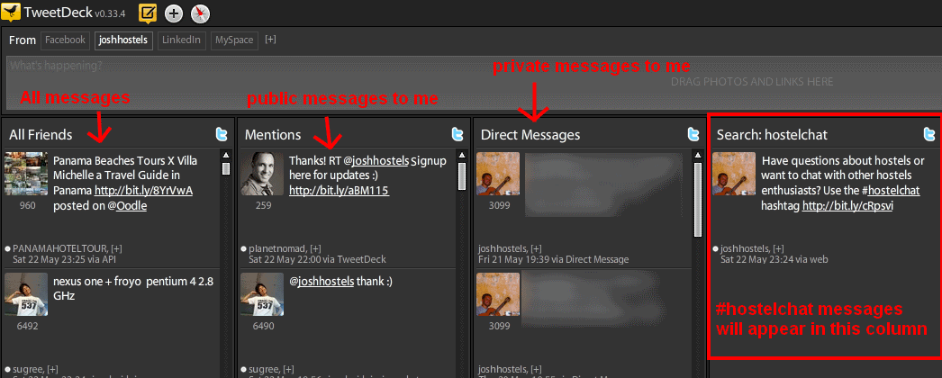
From: http://www.hostelmanagement.com/forums/hostelchat-hashtag-twitter.html
Use this link if you need to cite a Tweet: http://guides.boisestate.edu/content.php?pid=19556&sid=586398
Rule to Follow: Don’t let Twitter overwhelm you! This is a tool that you can jump in and out of for days or months at a time. Take what is useful and don’t worry about what you may miss.

